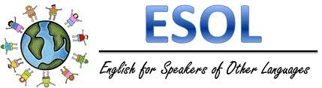

### Montessori Academy

Rochester, NY

December 2016

Ms. Harris’s Classroom Newsletter

# 4th Grade

We have started our unit on informational text. Your student is refamiliarizing herself with the parts of an informational text (table of contents, fact boxes, glossaries, indexes, etc.). We will soon use an informational text to answer text based questions using evidence from the text, and analyzing the evidence to form a short constructed response.

We are well into the novel *Island of the Blue Dolphin*. We will continue to improve understanding of vocabulary, but also focus on heavily on comprehension skills and using evidence from the text to support their answer. Every week, your student is given two comprehension questions for 3-4 chapters, requiring them to gather evidence, analyze the evidence, and write a constructed response. In each constructed response, students have a topic sentence, supporting details, and a conclusion sentences.

# 5th Grade

We finished our unit on homophones, and are now working on parts of speech. We have reviewed nouns and regular verbs from our learning last year, before learning about irregular past, present, and future verbs.

Your student has just started learning about adverbs, which is a descriptive word for verbs, adjectives, and other adverbs. They are learning through sorting the types of adverbs, sentence analysis with adverbs, and incorporating adverbs in their own writing.

Winter break will be starting soon. Break starts December 24th and ends January 2nd. The ESOL students will be having a winter celebration in my room during lunch on the 23rd of December. Your student is invited to bring a snack or drink to share with the other students. I will be providing cake and sambosa, a popular snack in Asian and North African cultures. They are similar to empanadas.

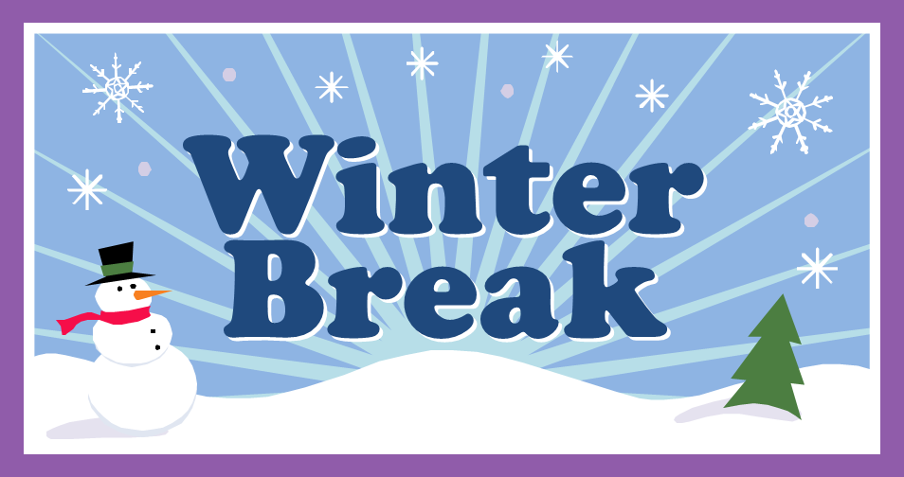

# 2nd Grade

Your students have been focusing on sentence structure of simple sentence and compound sentences in our reading and writing. We used the facts and details we have learned in our reading about the Iroquois in our writing.

We will continue to write and read compound sentences, but we will begin to use different text about colonial times.

# 3rd Grade

# What’s new?